Your ideas and opinions concerning

interior design

- List four words or phrases that describe your interior design tastes.
  - ______________________
  - ______________________
  - ______________________
  - ______________________

- List four needs that your housing must meet.
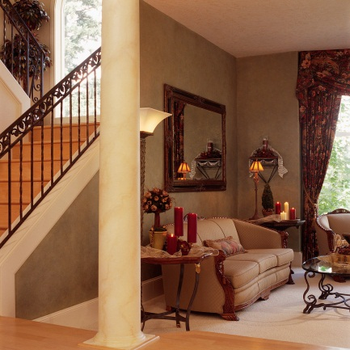
  - ______________________
  - ______________________
  - ______________________
  - ______________________

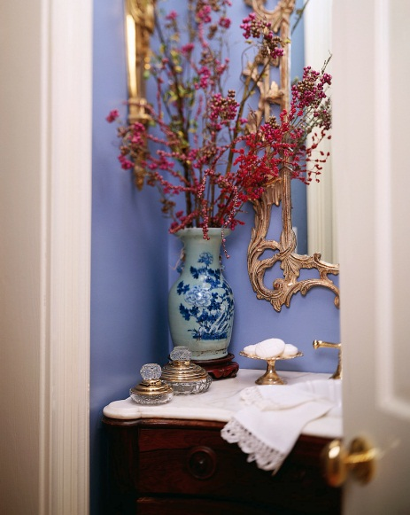
- List four items that you have always dreamed of having in your house.
  - ______________________
  - ______________________
  - ______________________
  - ______________________

What is Interior Design?

Who are we designing for?

Professionalism and Presentations

When working with clients, it is important that we portray ourselves and our work in a professional manner. The things listed below are key points to becoming excellent presenters and being able to show our ideas neatly so that they are appealing to the eye. Remember: this is how you are able to get a job; if it is not presented well, someone else will get hired.

YOU….
- ________________________

- ________________________

- ________________________

- ________________________

- ________________________

- ________________________

- ________________________

Visuals…

- ________________________________
- ________________________________
- ________________________________
- ________________________________
- ________________________________
- ________________________________
- ________________________________
- ________________________________

Presentation methods and explanations:
- _________________________

- _________________________

- _________________________

- _________________________

- _________________________

- _________________________

- _________________________

- _________________________

- _________________________

