Scale is: ______________________________________________________________________________________________________________________________________________________________________________________________________________________________________________________________________________
Proportion is: _____________________________
____________________________________________________________________________________________________________________________________________________________________________________________________________________________________
_________________________________________________________

Golden mean: _________________________________________________

_____________________________________________________________________________________
_____________________________________________________________________________________________________________________________________________

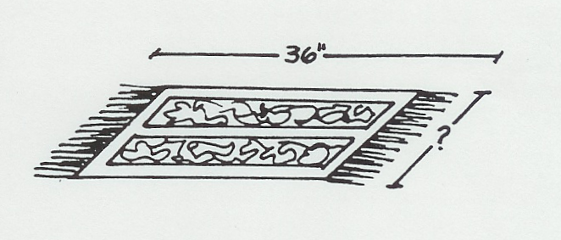
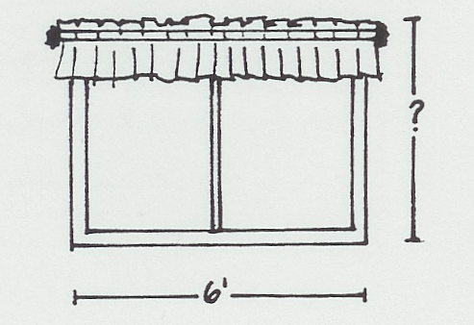
Computing scale:
1 2.

What are the missing measurements?
- 2.

Scale is: ______________________________________________________________________________________________________________________________________________________________________________________________________________________________________________________________________________
Proportion is: _____________________________
____________________________________________________________________________________________________________________________________________________________________________________________________________________________________
_________________________________________________________

Golden mean: _________________________________________________

_____________________________________________________________________________________
_____________________________________________________________________________________________________________________________________________

Computing scale:
1 2.

What are the missing measurements?
- 2.

