Foods and Nutrition I Workbook

Name: ____________________________________



Ms. Davis

**Hand me the whatchamacallit…….**

Pizza Pan #______

Red cutting board #_______

Dry Measuring cups #_______

Liquid Measuring cups #______

2 Turners #_______

Bosch Mixer #_______

2 Muffin Tins #_______

3 Rubber Spatulas #_______

Cake Pan #________

Dinner Plate #________

Rolling Pin #________

Biscuit Cutter #________

Waffle Iron #________

Bread Pan #________

2 Skillets #________

Electric Mixer #________

2 Chef Knives #________

Cereal Bowls #________

Spatula #________

4 Metal Mixing Bowls #______

Dish Soap #_______

Can opener #_______

Cookie Sheet #_______

Silverware #_______

Pizza Cutter #_______

Square Glass Pan #_______

Salad Plate #_______

Tongs #_______

Apple Corer #_______

Drinking Cups #_______

Blender #_______

Egg Separator #_______

2 Saucepans #_______

Pastry Blender #_______

Colander #_______

Paring Knife #_______

Pastry Brush #_______

Vegetable Peeler #_______

Dish Drainer #_______

Kitchen Shears # ________

2 C liquid measuring Cup #_______

Measuring Spoons #______

Cheese Grater #_______

Water Pitcher #________

Red Tray #________

Whisk #_______

2 Wooden Spoons #_______

Sifter #________

Placemats #_______

Stabilizers #_______

4 Custard Cups #________

Oven Mitts #________

Hand Soap #_______

Green Cutting Board #______

Meat Thermometer #_______

Metal Square Pan #_______

Slotted Spoon #_______

2 qt. Mixing Bowl# _______

Dust Pan #_______

Ice ________

Dish Rags ________

Hand Towels ________

Aprons ________

**Lab Rules**

1. Complete Jobs Assignment

|  |  |
| --- | --- |
| 1 | * Place measuring tools on Red Tray * Go to supply table and get ingredients * HELP with cooking |
| 2 | * Fill one sink with **HOT** soapy water * Get dish rag from laundry area * Wash dishes as you go * Rinse Dishes * HELP with cooking |
| 3 | * Fold any towels that are in the WHITE laundry basket and put them on the shelves * Get 2 hand towels from laundry area * Dry Dishes * HELP with cooking |
| 4 | * Put away all CLEAN & DRY dishes and equipment in CORRECT drawers and cupboards * Wipe off all counters and table at the end of lab * SWEEP after EVERY lab * HELP with cooking |
| 5 | * Set table * Help teacher clean supply table * Help with cooking |

*Note: If there are only 4 people in your unit one person will do both of these job. THEY STILL NEED TO BE DONE!

2. a). Wash hands for _____ seconds

b). Wear and apron

c). Tie hair back

d). Do NOT sit on counter

3. NO towel whipping

4. NO playing with bubbles in sink

5. EVERYONE must help prepare the food

Food Labs are worth 30 points

* 10 points for completing your assignment
* 10 points for safety and sanitation
  + hair tied back/ apron
  + No sitting on counter
  + kitchen clean
* 10 points for cooperation
  + Working with group and doing lab

One bad choice will result in you losing your cooking privilege for _____weeks.

I, ________________________have read and understood Ms. Davis’ rules and procedures in her classroom. If I misbehave or disrupt her classroom, I understand the consequences of my actions.

**Sanitation Study Guide**

**General**

1. What conditions are usually present for bacterial growth?

F.

A.

T.

T.

O.

M.

2. Wash hands with soap and water a minimum of ________________.

3. _______________________________ is the transfer of harmful bacteria from one food to another food.

**Temperatures**

1. What is the temperature danger zone? __________________

2. What temperature should the freezer be? _______________

3. What temperature should the refrigerator be? _______________

4. What temperature should ground meat be cooked to? ____________

5. What temperature should poultry be cooked to?______________

6. At what temperature should you hold hot foods?______________

7. At what temperature should you reheat food to?_____________

8. Use a clean thermometer to check the _________________ temperature of foods.

9. Cook eggs until the yolks are __________________.

**Holding, Cooling, Reheating**

1. Keep hot foods _____________ and cold foods ________________.

2. Foods should not be in the danger zone (sitting out) for more than _________________ - refrigerate or freeze as soon as possible.

3. Place food in ___________________ containers and refrigerate immediately.

4. Air in the refrigerator and freezer needs to ____________________ to keep things cool. Leave some space around the containers in your refrigerator and freezer.

5. When in doubt, _________________________________________!!

6. How long should you store leftovers? ____________________

7. Never place cooked food on a plate that has held ______ meat, poultry or seafood without washing it first.

**Thawing**

1. The safest way to thaw is in the ____________________; NEVER defrost at __________________________.

2. You can thaw in the ______________________, but you must cook the food immediately.

3. You can also thaw in a sink with ____________________________.

**Safety and Sanitation**

**When working with ELECTRIC APPLIANCES:**

1. Keep your hands dry.
2. Stand on a dry surface.
3. Keep electric appliances away from __________.
4. Avoid using _________ objects on electric appliances.
5. Unless absolutely necessary, avoid using an extension cord.
6. Do not ___________________ too many appliances into the same outlet. It could get over-loaded and explode or get overheated and cause a blackout.
7. When cleaning appliances make sure they are unplugged.
8. If someone is getting shocked by an appliance, first ____________________________________________, then unplug the appliance before approaching the injured person.

**To avoid CUTS:**

1. ___________________ knives are safer than dull ones.
2. Do not put knives in a drawer full of knives.
3. Store knives in a knife block or a knife rack.
4. Clean up any _________________________ immediately.
5. In the case of someone getting cut, the general rule is to ______________________ by using a clean cloth covering the wound and pressing directly on the wound.
6. Sometimes, you will need to apply pressure on the wound and on the nearest ______________________.

**To avoid getting BURNED:**

1. Stand to the ___________ of the oven when opening it.
2. Use hot pads for handling hot pans, etc. (This includes those coming out of the microwave.)
3. Lift the lids off of foods so the steam goes _____________________ from your face.
4. Pull the rack of the oven out rather than having to reach in.
5. Turn the pan handles toward the ________________ or ______________ of the stove.
6. If it is a __________________ degree burn, it will be red, but there will not be any blisters. In this case, you should _____________________________________________.
7. If it is a second degree burn, it will have blisters and be red. In this case you can cover with a cool cloth, or have a doctor check it if it is a large area.
8. If it is a third degree burn, the skin will be ________________ or melted away. In this instance, you should determine how large of an area is burnt, then call for help. Avoid _______________the burnt area and lightly cover the area with a cool cloth.

**How to avoid FALLS:**

1. Use a ___________________ to reach things in high places.
2. Clean any ________________ as soon as they happen.
3. If there is a fall, assess the injures:
   1. Make sure they are breathing.
   2. Check for bleeding.
   3. Make them comfortable.
   4. Remove them from activity path.

**To help prevent FIRES:**

1. Keep all flammable objects away from direct heat.
2. Never put paper towels on the range.
3. Watch your stove carefully. Never leave it unattended.
4. If it is a grease fire:
   1. Put a ________________ on it
   2. Pour __________________ on it
   3. Use a fire __________________________
5. Do **NOT** ever use:
   1. _____________________
   2. _____________________
   3. _____________________

**CLEANING and CLEANING SUPPLIES:**

1. You should keep all surfaces and equipment clean.
2. Wash the counter with a disinfectant before you begin to cook.
3. _______________________________. It will keep the area clean and will make the clean-up much easier.
4. To properly wash dishes:
   1. Throw away or rinse any food left on dishes
   2. Fill one sink with hot soapy water
   3. Fill the other sink with plain hot water
   4. Wash dishes in soapy water, then rise all soap away in the plain hot water
   5. Place dishes in dish rack or dry with a clean towel
5. When you are doing the final clean-up, you should wash the dishes in the following order:
   1. **_______________________________**
   2. **_______________________________**
   3. **_______________________________**
   4. **_______________________________**
   5. **_______________________________**

**To prevent POISIONING and CONTAMINATION by cleaning supplies:**

1. Keep all chemicals away from the food. Store them in a different place than you store your food.
2. Keep supplies in their _______________________________________ and make sure they are labeled with their contents, what they are there for, and how to use them.
3. The safest rule as far as mixing cleaning supplies is: **DO NOT MIX THEM**!
4. Combinations like ________________ and _____________ will produce a deadly ________________!

**Sanitation Rules:**

1. Always wash hands for a minimum of _______________________.
2. Wash your hands:
   1. ___________________ Cooking
   2. ___________________ Cooking
   3. ___________________ Cooking or Handling Raw Meat
3. Wear gloves while cooking if you have a cut or open sore on your hands.
4. Pull back or cover hair while working in the kitchen.
5. Use plastic cutting boards, not wooden ones.
6. When tasting foods, use a clean spoon every time.
7. Keep foods out of the _____________________________________________________**.**
8. Foods should be stored within two hours.
9. Always check the internal temperature of foods with a food thermometer.
10. Ground meats, such as ground beef, should be cooked to at least ______________.
11. Keep hot foods _______________ and cold foods _________________.
12. When in doubt, __________________________!
13. The best ways to _____________________frozen food:
    1. _____________________________________________
    2. _____________________________________________
    3. _____________________________________________

**Handling Emergencies**

1. You get a minor cut on your knuckle while grating cheese. What do you do? ____________________________________________________________________________________________________________________________________________________________
2. You burn the back of your hand on an oven rack. What do you do? ____________________________________________________________________________________________________________________________________________________________
3. Your mother falls off of a step stool and you think her ankle may be broken. What do you do? ____________________________________________________________________________________________________________________________________________________________
4. A child in your care has just swallowed some type of leaning fluid in an unlabeled bottle. What do you do? ____________________________________________________________________________________________________________________________________________________________
5. You find your sister lying on the kitchen floor. A portable mixer, still plugged in, is in the sink and the water is running. You suspect your sister has received an electric shock. What do you do? ____________________________________________________________________________________________________________________________________________________________
6. You are having dinner with a friend when she suddenly puts her hand to her throat. She cannot speak and her face is beginning to turn blue. What do you do? ____________________________________________________________________________________________________________________________________________________________
7. You gash your wrist with a meat cleaver. Blood is spurting out of the seep wound. What do you do? ____________________________________________________________________________________________________________________________________________________________
8. Your grandmother serves chicken for dinner. Later, she complains of a severe headache, abdominal pain, and vomiting. You suspect she is suffering from salmonella. What do you do? ____________________________________________________________________________________________________________________________________________________________

[](javascript:edit(23877))

**Food Bourne Illnesses**

|  |  |  |
| --- | --- | --- |
| **Disease** | **Source** | **Symptoms** |
| **Botulism** |  |  |
| **E-Coli** |  |  |
| **Salmonella** |  |  |
| **Staphylococci** |  |  |
| **Hepatitis A** |  |  |

**Reading a Recipe and Measuring**

1. List the FOUR parts of a recipe:

1. _______________________________________________________________
2. _______________________________________________________________
3. _______________________________________________________________
4. _______________________________________________________________

2. What are the EIGHT steps to following a recipe correctly?

1. Read the recipe carefully before beginning
2. Check to see if you have all the ingredients
3. Pre-heat oven if needed
4. ”Gather” all equipment needed
5. Complete preparation of specific ingredients (Ex: chopped nuts, melted chocolate)
6. Measure exactly
7. Mix carefully, following each direction
8. Bake or cook at temperature and time directed

3. What is the most important step and why?

_________________________________________________________________

_________________________________________________________________

4. Before cooking, you should always wash your hands for at least how long?

_____________________

5. What should you NEVER do when measuring flour?

_________________________________________________________________

How should you measure flour instead?

_________________________________________________________________

6. What is the most efficient way to measure the following measurements of dry ingredients?

4 Tbsp. =_____________________ 3 tsp. = ____________________

3/4 c. = ______________________ 1/8 c. = ____________________

7. When cutting a recipe in half, or when doubling a recipe:

The cooking ___________________ remains the same, but the ________ of the cooking pan and the length of ___________ will be affected.

1. When baking with a glass dish, you need to reduce (lower) the oven temperature by _________ degrees.

Know Your Abbreviations

|  |  |  |  |  |  |  |
| --- | --- | --- | --- | --- | --- | --- |
| T., Tbsp. | = | ____________________ |  | lb., # | = | ____________________ |
| oz. | = | ____________________ |  | pkg. | = | ____________________ |
| c. | = | ____________________ |  | pt. | = | ____________________ |
| t., tsp. | = | ____________________ |  | gal. | = | ____________________ |
| qt. | = | ____________________ |  | hr. | = | ____________________ |

**Know Your Equivalents**

|  |  |  |  |  |  |  |
| --- | --- | --- | --- | --- | --- | --- |
| 1 Tbsp. | = | ________ tsp. |  | 1/2 c. | = | ________ Tbsp. |
| 1 c. | = | ________ Tbsp. |  | 12 Tbsp. | = | ________ c. |
| 1/3 c. | = | ________ Tbsp. |  | 2 Tbsp. | = | ________ c. |
| 1 stick/cube butter | = | ________ c. |  | 1 stick/cube butter | = | ________ Tbsp. |
| 1/4 c. | = | ________ Tbsp. |  | 4 Tbsp. | = | ________ c. |
| 16 Tbsp. | = | ________ c. |  | 2 pt. | = | ________ qt. |
| 1 pt. | = | ________ c. |  | 1 gal. | = | ________ qt. |
| 1/8 c. | = | ________ Tbsp. |  | 1 gal. | = | ________ pt. |

**Doubling and Halving Recipes**

|  |  |  |
| --- | --- | --- |
| Doubled | Ingredients | Halved |
| ______________________ | 1 ½ c. sugar | ______________________ |
| ______________________ | ¼ c. brown sugar | ______________________ |
| ______________________ | 2/3 c. peanut butter | ______________________ |
| ______________________ | 2 ¼ c. oats | ______________________ |
| ______________________ | ¾ c. milk | ______________________ |
| ______________________ | 1 tsp. salt | ______________________ |
| ______________________ | 2 tbsp. cocoa | ______________________ |
| ______________________ | 1 tsp. vanilla | ______________________ |
| ______________________ | 2 eggs | ______________________ |
| ______________________ | 3 c. flour | ______________________ |
| ______________________ | 12 oz. walnuts | ______________________ |

Cooking Terms

**Match the correct words to the correct definitions.**

Mince

Dredge

Knead

Dice

Cream

Fold-in

Whip

Steam

Sauté

Cut-in

Pare/Peel

Grate

Chop

Boil

Simmer

1.________________:To beat sugar and fat together until fluffy.  
2.________________:To cut fat into flour with a pastry blender.

3.________________:To cut food into small, irregular pieces.

4.________________:To cut into very small cubes***.***

5.________________:To mix ingredients gently, turning one part over another w/ a rubber spatula.

6.________________:To finely shred food by rubbing it on a tool with sharp projections.

7.________________:To work dough with the “heel” of the hands until it is smooth and elastic.

8.________________:To coat food evenly with an ingredient like breadcrumbs or cornmeal.

9.________________:To remove the skins of soft fruits and vegetables.

10._______________:To cook in a small amount of fat, usually in a skillet or a wok.

11._______________:To cut or chop food as finely as possible.

12._______________:To cook below boiling point; bubbles form, but it never comes to a full boil.

13._______________:To beat a food rapidly in order to add air into food.

14._______________:To cook in the vapor generated by boiling water.

15._______________:To heat liquid until bubbles continuously rise to the surface

Microwave Cooking

1. Microwaves are ATTRACTED to:

a. _______________

b. _______________

c. _____________

2. Microwaves are REPELLED by:

a. _____________

3. What materials or containers are microwave safe?

a. _______________

b. _______________

c. _______________

4. What part of the microwave oven generates the microwaves?

5. Which container cooks more evenly-Round or Square? WHY?

6. What is standing time and WHY is it important?

**WHAT:** The amount of time food is allowed to sit _____________ microwave cooking in

order to_____________________________________.

**WHY:** If you don’t allow for standing time, you will ___________________________.

7. Why should you stir or rotate food when microwave cooking?

8. What part of the microwave will rotate the food *while* it is cooking?

9. Why is it best to cover most foods when microwave cooking?

1. ________________________________________
2. ________________________________________
3. ________________________________________

10. Why do foods NOT brown in the microwave?

11. How can you prevent burns when microwave cooking?

a. _________________________________________

b. _________________________________________

c. _________________________________________

**Quick Breads**

**Characteristics**

**Gluten**: When water is mixed with flour, the proteins in the flour give strength and elasticity to batters and doughs. **Kneading**: To work a dough with the palms of the hands to develop gluten.

Rice & Pasta

1. List the types of rice below:

|  |  |
| --- | --- |
| **Type** | **Description** |
| A. | Shorter than long grain rice. When cooked, it is moist and tender. |
| B. | 4-5 times longer than the width. After cooked, it will be light and fluffy. |
| C. | Short, plump and almost round. Cooked grains are soft and cling together. |
| D. *Has the most fiber! | Chewy texture and “nut-like” flavor. Rich in vitamins, minerals and fiber. |
| E. | Long, dark and streaky color. Distinct flavor. |
| F. | It has been completely cooked and then dehydrated. The process reduces time required for cooking. |

2. **To cook rice:**

A. Use about 2 cups of water for every cup of rice.

B. Bring water to a boil.

C. Add rice and ______________________________.

D. Bring water back up to a boil.

E. Reduce heat so rice will simmer.

F. Check for doneness. The rice should be tender but firm, and there should be no water left.

G. If some water remains, continue cooking, but remove the lid.

3. **RICE YIELD:**

_______________ uncooked rice will make _______________cooked rice (1:3 ratio)

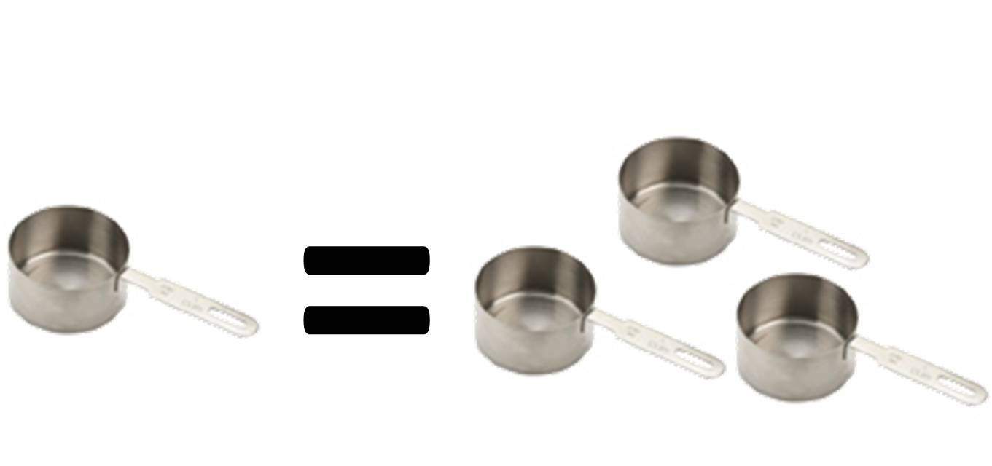

4. **To cook pasta:**

A. Use about 1 quart of water for every 4 ounces of dry pasta.

B. Bring water to a boil.

C. Add pasta slowly to boiling water so boiling does not stop.

D. _______________________________________.

E. Stir pasta frequently while it’s cooking.

F. Cook pasta to al dente stage (pasta remains firm to the bite).

G. Drain pasta in a colander.

H. To keep pasta warm, set the colander over a pan of hot water and cover the colander.

5. **PASTA YIELD:**

____________________ uncooked pasta will make ___________________ cooked pasta (1:2 ratio)

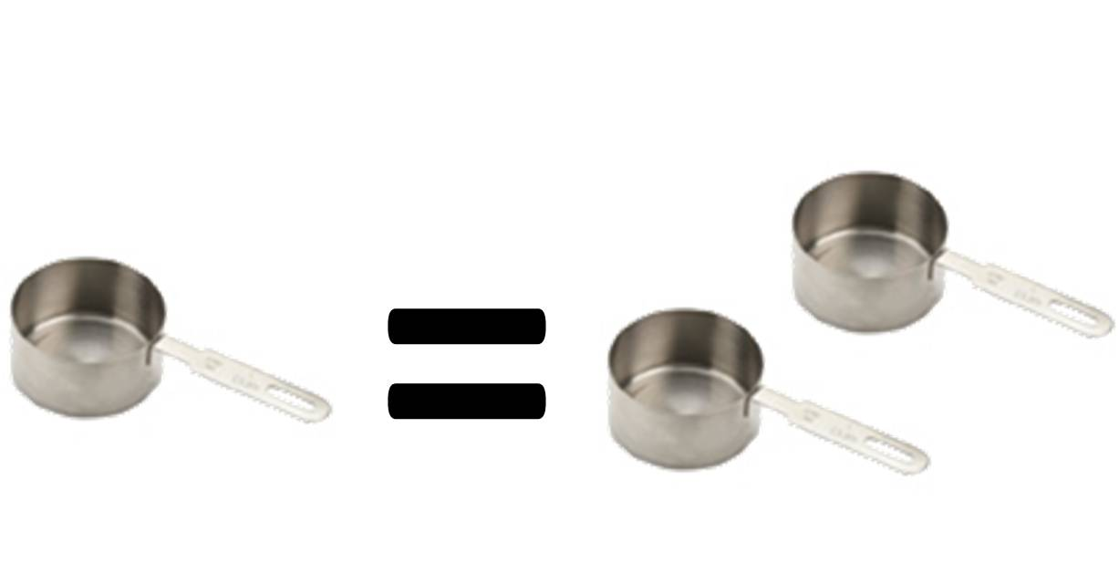

MILK

1. It is recommended that we _________________________________________________________ and get at least _______________________ daily from the Dairy food group.
2. Milk and milk products, (yogurt, cheese, etc.) are excellent sources of ___________________ ________________________because they come from animal sources.

1. By law, milk must be fortified with _____________________________________________.
2. ______________________________ means that “EXTRA” has been added to the project.
3. You can also get Vitamin D from ________________________. That is why it is sometimes called the “_____________________ VITAMIN”.
4. Milk products also provide important minerals like CALCIUM, IRON and PHOSPHORUS to help build healthy bones and teeth.
5. Milk goes through several treatments before it is safe to drink. Two of these processes are:
   1. _________________________________: milk that has been HEAT TREATED to remove or kill harmful organisms.
   2. _________________________________: the fat particles in milk have been BROKEN DOWN and evenly distributed so they cannot join together again.
6. There are several types of Milk:

|  |  |
| --- | --- |
| Type of Milk | Description |
| a. WHOLE MILK | Contains the highest amount of fat-(At least 3.25% or more) |
| b. 2% MILK | Contains only 2% milk-fat |
| c. 1% MILK | Contains only 1% milk-fat |
| d. SKIM MILK (FAT-FREE MILK) | Contains no fat |
| e. NON-FAT DRY MILK | Skim milk that has been dehydrated and packaged |
| f. EVAPORATED MILK | Milk that has had all water evaporated out of it |
| g. SWEETENED CONDESNSED MILK | Milk with sugar added and then had water evaporated out |
| h. UHT MILK (Ultra High Temperature) | Milk heated to 280° for 2 seconds to kill bacteria |
| i. LACTOSE FREE MILK | Milk that has had the lactose sugar removed |
| j. BUTTERMILK | Milk with lactic acid added |
| k. ACIDOPHILUS MILK | Special milk to help those with digestive disorders |
| l. FLAVORED MILK | Milk with flavorings added (chocolate, strawberry, etc.) |

1. Milk products _______________________ easily.
2. Scorching occurs when the proteins in milk are _____________________________. They fall and cling to the bottom of the pan. They create a thick, black layer that is difficult to remove.
3. To prevent scorching, cook milk on ___________________ and STIR IT ________________________to prevent the proteins from collecting on the bottom of the pan.

Heating milk in the ________________________ will also prevent scorching.

Fruits and Vegetables

FRUITS

Nutrition

* Fruits are 75 – 95% water
* Low in _______, _________ and _____________
* Excellent source of _________ (especially the skins!)
* Vitamins/Minerals Fruits Provide:
  + Vitamin C
  + Vitamin A
  + Potassium
* Choose ____________ or ______________ fruits more often than fruit juice.
* __________, ________ and ___________ can destroy nutrients in both fruits and vegetables.
* Always _______ fruits and vegetables to remove pesticides that might remain on the skin.

Guidelines for Selection Fruits

* Firm • Crisp
* Free from Decay • Smooth
* Dense • Good Color
* Free From Bruises • Good Smell
* In Season (Will Be Cheaper)

Purchasing and Storing Fruits

* Store Fruits in:
  + _______________________
  + _______________________
  + _______________________

Ripening

* __________ happens when____________ found in the fruit break-down into ________
* This leads to deterioration or spoilage:
  + Color Lightens
  + Texture Softens
  + Decreases in Acidity
  + Increases in Sweetness

Browning

* ____________________ occurs when the cut surfaces of food reacts with oxygen.
* This is called __________________.
* To prevent this, cover cut fruits with a liquid containing _____________________________

VEGETABLES

Nutrition

* Vegetables provide the following vitamins and minerals:
  + Vitamin A
  + Vitamin C
  + Vitamin D
  + Potassium
  + Folic Acid
  + Calcium
  + Magnesium
  + Vegetables contain NO __________________
  + They are low in _____________, ________ and _____________ (They are “______________ ________________”)
  + Eat more ___________, ______________ and _________________________ vegetables form the vegetable group.

Best Cooking Methods for Preserving Nutrients

* The two BEST methods are:
  + ___________________________
  + ___________________________
* You can also:
  + Bake
  + Stir-Fry
  + Simmer
  + Sauté

Five Ways to Preserve Nutrients When Cooking Fruits and Vegetables

* Cook in __________________ pieces
* Use ___________ amounts of ____________
* Cook only until ________________________
* Cook ________________________
* _____________________________ used to cook in for soups and gravies (most nutrients dissolve into the water)

MyPlate Notes

Label and color each food group. Then, list the key consumer message for each.

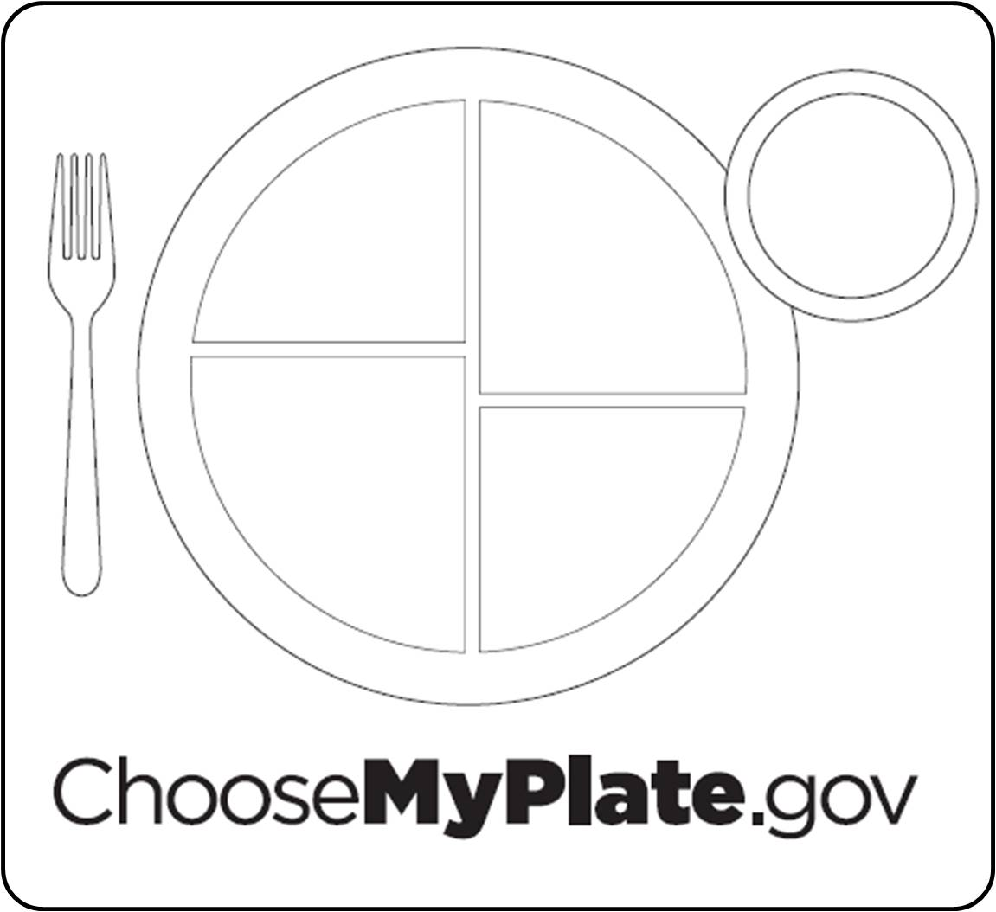

Your Serving Sizes

List the serving sizes from each food group that YOU need daily.

|  |  |  |  |
| --- | --- | --- | --- |
| Food Group | Serving Size | Food Group | Serving Size |
| Fruits |  | Grains |  |
| Vegetables |  | Dairy |  |
| Protein |  |  | |

Dietary Guidelines

Revised every _________ years

1. Eat foods.
   * Nutrient Dense: _______________________________________________________ ____________________________________________________________________
2. Balance to manage weight.
3. sodium, fats and added sugars, refined grains and alcohol.
4. vegetables, fruits, whole grains, milk seafood and use oils in place of solid fats.
   * Chose _______________ products in the place of some meat and poultry per week.
5. Build healthy ___________________that meet nutritional needs over time at an appropriate calorie level.
6. Include ______________________ as part of healthy eating patterns.

6-17 year olds should be active at least _____________________ or more each day.

Healthy Eating Patterns

1. Balance calories:
   * Enjoy your food, but eat ___ .
   * Avoid ____ portions.
2. Foods to increase:
   * Make half your plate .
   * Switch to fat-free or low-fat .
   * Make at least half your grains .
3. Foods to reduce:
   * Compare in foods like soup, bread and frozen meals and choose foods with the numbers.
   * Drink instead of sugary drinks.
4. Oils:
   * Oils are not a food group, but they do provide nutrients.
   * Choose oils that provide fats.
5. Individual caloric needs:
   * Each person’s caloric needs depends on _____, and _________________.
6. Empty calories:
   * Foods that have and added ____________ add calories to food, but few or no .
   * In some foods, like candies and soda, _________ the calories are empty calories.
   * A small amount of empty calories are okay, but most people eat far more than what is _________________.

|  |  |
| --- | --- |
| My Daily Oils Recommendations |  |
| My Daily Caloric Needs |  |
| My Daily Limit for Empty Calories |  |

Carbohydrates

1. We get most of our carbohydrates from the __________________ group.

2. ________________ and ____________________ are also a good source of carbohydrates.

3. Almost all of our carbohydrates come from ____________________ food sources.

4. The main function of carbohydrates is to ___________ _________. They provide _____ calories per gram.

5. If we eat more carbs than our bodies need for energy, they get stored as ____________.

6. The three types of carbohydrates are:

a. ____________________________

b. ____________________________

c. ____________________________

7. Sugars are ______________. Starches are __________________.

8. Complex Starches will ______________________ into Simple Sugars.

**Draw a Picture of the Following and CIRCLE the Better Energy Source:**

|  |  |
| --- | --- |
| SIMPLE SUGAR | COMPLEX STARCH |
|  |  |

9. List the different types of sugars and their food sources:

|  |  |  |
| --- | --- | --- |
| **SUGAR** | **OTHER NAME** | **FOOD SOURCES** |
| A. | “Blood Sugar” | Fruit, Vegetables, Grains |
| B. | “Table Sugar” | Table Sugar, Sugar Cane |
| C. | “Fruit Sugar” | Fruit |
| D. | “Malt Sugar” | Grains |
| E. | “Milk Sugar” | Milk |

Fiber

1. The average American does not get enough __________________ in their diets.

2. The National Cancer Institute recommends that the average person gets _____________ of fiber every day.

3. Two other common names for fiber are: ________________ or __________________

4. Fiber is important because it attracts _____________ to the _________________ and helps move food through our systems faster. You have to have water along with fiber or it is not as effective.

5. Benefits of fiber include a lowered risk of ____________________, hemorrhoids and colon or rectal cancer.

6. List the two types of fiber and the main functions they perform:

|  |  |
| --- | --- |
| **Type of Fiber** | **Function** |
| A. | Show to lower total blood cholesterol |
| B. *Will NOT digest or dissolve | Helps move food through the body |

7. __________________ is insoluble, or ________________________.

8. Fiber only comes from _________________ food sources. You CANNOT get fiber from animal food sources.

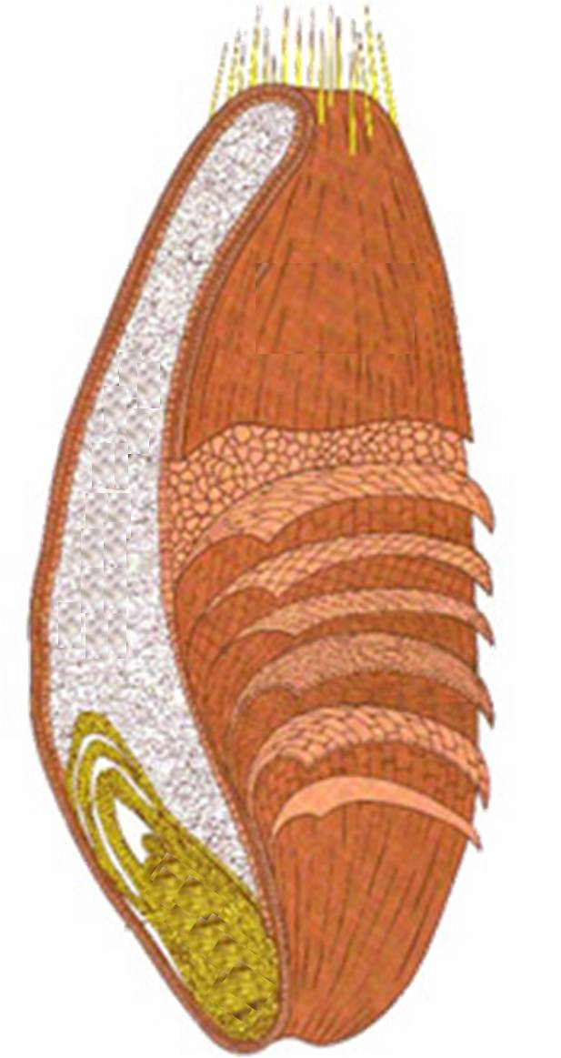9. Foods that are high in fiber include:

A. ______________

Provides:

Starch

Protein

a. ____________________________________

b. ____________________________________

c. ____________________________________

B. _______________

Provides:

Unsaturated Fatty Acids

“B” Vitamins

Vitamin E

Iron

Zinc

Other Trace Minerals

d. ____________________________________

10. Ways to increase fiber in the diet include:

a. ___________________________________

b. ___________________________________

c. ___________________________________

11. **Label the wheat kernel to the RIGHT:**

12. The MOST beneficial part of the wheat kernel is: ______________________

13. The LEAST beneficial part of the wheat kernel is: ______________________

14. When a product claims that is it “Whole Wheat” or “Whole Grain”, it must use the ______________ wheat kernel, or all three parts.

C. _________

Provides:

Fiber

Vitamins

Minerals

15. Other products, like white bread and rice, usually only use the _______________, which is the _____________ beneficial part of the wheat kernel.

16. ___________________: some of the nutrients that were lost in processing are added back into the product

17. ___________________: 10% more of the Daily Value for the nutrient is being added

Yeast Breads

1. What is the purpose of each ingredient in yeast breads?

|  |  |
| --- | --- |
| **Ingredient** | **Function** |
|  | Body/Structure |
|  | Produces CO2, provides leavening to make light, airy and porous |
|  | Controls yeast and adds flavor |
|  | Provides tenderness |
|  | Dissolves and activates yeast |
|  | Food for yeast |
|  | Provides color, texture and nutrients |

2. What is proofing?

The period of time when the bread is _______________ and ____________ is being produced.

3. What happens if the liquid you add to the yeast is too hot?

4. What happens if the liquid you add to the yeast is too cold?

5. What affect does salt have on yeast?

6. What is the effect of mixing baking soda with an acid?

7. What are some common acids added to foods to help produce leavening? (List at least 3)

Protein

PROTEIN

1. Proteins provide _________ calories per gram.
2. The main function of protein is to ___________________________________________________.
   * If carbohydrates and fat are not available, your body will use protein. Is this a good thing? _______
3. You must eat protein __________________ to replace the wear and tear on the body tissues.
4. We get most of our protein from the ________________________________________.
5. It is recommended that we choose _________________________________ products in the place of some meat and poultry every week.
6. ________________________ are the “__________________________________” of protein.
7. There are ________________ essential amino acids.
8. _________________________________ means that your body MUST have them.
9. _________________________________ contain all 9 of the essential amino acids.
10. Complete proteins com from ________________________ sources.
11. _____________________ (from soybeans) is the only complete protein from a plant source.
12. ___________________________________________ do NOT contain all of the essential amino acids.
13. Incomplete proteins come from ___________________________ food sources.
14. Examples of incomplete proteins could be:
    1. GRAINS d. RICE
    2. BEANS e. WHEAT
    3. NUTS/SEEDS
15. Incomplete proteins can be ____________________________________ to create a complete protein.
16. Examples include:
    1. BEANS AND RICE
    2. PEANUT BUTTER AND WHOLE WHEAT TOAST
    3. BEAN SOUP WITH A WHEAT ROLL

CHEESE

1. There are two types of cheese: _______________________ and ____________________________.
2. Natural cheeses include:

|  |  |
| --- | --- |
| Type of Cheese | Examples |
| a. FRESH (Unripened) | Cream Cheese, Feta, Mozzarella, Ricotta |
| b. SOFT CHEESES | Brie, Boursin, Camembert |
| c. SEMI-SOFT CHEESES | Fontina, Gorgonzola, Couda |
| d. FIRM CHEESES | Cheddar, Gruyere, Provolone |
| e. HARD CHEESES | Asiago, Parmesan |

1. Processed cheese is cheese made from natural cheeses, but has had emulsifiers, colorings and PRESERVATIVES added to INCREASE SHELF-LIFE. It is also easier and cheaper to produce.
2. Processed cheese include:

* American Cheese (Cheese Singles), Easy Cheese (Spray Cheese), Velveeta, Powdered Cheese

1. To reduce fat intake in the Milk and Dairy Group, you can:
   1. ________________________________________________________
   2. USE A LOWER FAT CONTENT CHEESE________________
   3. SUBSTITUTE YOGURT FOR MAYONNAISE_____________

EGGS

1. Eggs are very porous. They should be __________________ in their ____________________________. The cardboard helps block unwanted odors from seeping into the eggs.
2. Eggs have an expiration date printed on the carton. They usually last _________________________.
3. Methods of cooking eggs include:
   1. HARD COOKED d. FRIED
   2. SOFT COOKED e. POACHED
   3. SCRAMBLED
4. When eggs are cooked, they __________________. This means that the liquid transforms into a solid.
5. Eggs perform different jobs in different foods. These include:
   1. ________________________ Example: ________________________
   2. ________________________ Example: ________________________
   3. ________________________ Example: ________________________
   4. ________________________ Example: ________________________
   5. ________________________ Example: ________________________

Fats and Oils

1. Fat is:
   1. The most _________________________ source of food energy.
   2. There are ____________ calories in every gram of fat.
   3. We should _________________________ from foods containing a lot of fat.
2. Fats that are __________________ are room temperature are called __________.
3. Fats that are ______________ or firm at room temperature are called _________.
4. Cholesterol is:
   1. Cholesterol is ______________fat.
   2. It is a “___________________” substance present in all body cells that is needed for many _______________________ body processes.
   3. It contributes to the _______________________ and the skin’s production of _______________________.
   4. Adults _________________all the cholesterol they need, mostly in the liver.
   5. All ____________________also have the ability to manufacture cholesterol.
5. Cholesterol in Foods:
   1. Because all animals make cholesterol, if you eat any animal product, including ____________, _______________ and ____________, you will be consuming some “extra” or unneeded cholesterol.
   2. Other foods high in cholesterol are:
      * + Egg Yolks
        + Liver / Organ Meats
        + Some Shellfish
6. LDL’s and HDL’s:
   1. A certain amount of cholesterol __________________ in the blood. It does not float through the bloodstream on its own, but in chemical “packages” called _____________________. There are two major kinds of lipoproteins:
      1. __________ (Low-Density Lipoproteins)
      2. __________ (High-Density Lipoproteins)
7. Low-Density Lipoproteins: ***“Losers”***
   1. Takes Cholesterol _______ the ______ to wherever it is needed in the body.
   2. If too much LDL cholesterol is circulating, the ___________ amounts of cholesterol can ________________ in ________________ walls.
   3. This buildup _______________the risk of ________________or _________.
   4. Thus, LDL cholesterol has come to be known as “_____________________.”
8. LDL’s are like the “____________________.”
   1. When LDL’s have too much cholesterol to cart around, it builds up in the arteries and starts to clog them up.
9. High-Density Lipoproteins: “***Heroes***”
   1. Picks up excess cholesterol and takes it ___________ to the ____________, keeping it from causing harm.
   2. Thus, HDL cholesterol has come to be known as “_____________________.”
10. HDL’s are like the “_____________________”
    1. The HDL’s go around and pick up all the excess cholesterol clogging up the arteries and take it back to the liver.
11. For most people, the _______________ and ______________ of fats eaten have a ________________ effect on blood cholesterol than does the cholesterol itself.
12. The fats found in food, such as butter, chicken fat, or corn oil, are made up of different combinations of _______________________.
13. Types of Fat:
    1. Fatty acids: **ORGANIC ACID UNITS** that make up fat. There are three types…
       1. ________________________
       2. ________________________
       3. ________________________
14. **SATURATED** Fatty Acids:
    1. ____________ HDL’s
    2. ____________ LDL’s

**Food Sources:** Meat/Animal Sources, Poultry Skin, Whole Milk & Dairy Products, Butter, Shortening, *Tropical Oils

1. **POLYUNSATURATED** Fatty Acids
   1. ____________ HDL’s
   2. ____________ LDL’s

**Food Sources:** Most Vegetable Oils, Corn Oil, Soybean Oil, Safflower Oil

1. **MONOUNSATURATED** Fatty Acids ***“The BEST One To Have!”***
   1. ____________ HDL’s
   2. ____________ LDL’s

**Food Sources**: Olives, Olive Oil, Avocados, Peanuts, Peanut Oil, Canola Oil

1. All fats include _______________ kinds of fatty acids, but in varying amounts.
2. A Good Rule of Thumb…
   1. Fats that are ___________ at room temperature are made up mainly of ____________________ fatty acids.
   2. Fats that are _________________ at room temperature are made up mainly of _______________________ fatty acids.
3. _________________________ Is:
   1. The process in which missing **HYDROGEN ATOMS** are added to an unsaturated fat to make it _______________ in texture. (It turns liquid oil into solid shortening.)
   2. This forms a new type of fatty acid called _______________________, (“man-made” fat).
   3. Trans-fatty acids have many of the same properties as ______________ fats.
4. Visible Fat:
   1. Fat that is _________________________
   2. Examples: Butter on a baked potato, layer of fat around a pork chop, etc.
5. Invisible Fat:
   1. Fat that ___________________________ by the eye
   2. Examples: whole milk, some cheese, egg yolks, nuts, avocados, etc.
6. Functions of Fat:
   1. Carries Vitamins ____, _____, _____ and ______ through the body.
   2. Provides a _________________ store of energy.
   3. Promotes healthy _____________
   4. Promotes normal _____________________
   5. Acts like a “________________” and heat regulator to protect your heart, liver and other vital organs.
   6. ____________________ your body.
   7. Satisfies hunger and helps you feel ______________ longer.
   8. Adds _________________ to food.
7. Too Much Fat…
   1. Americans eat not only too much fat, but the wrong kinds of fat! Doing so can increase the risks for serious health **CONCERNS** and **ILLNESSES**.
8. High fat diets are liked to:
   1. _________________________________
   2. _________________________________
   3. _________________________________
   4. _________________________________
9. Lowering Fat and Cholesterol in the Diet:
   1. _________________!
   2. Replace saturated fats with _____________________ fats in the diet.
   3. Choose ________________ cuts of meat.
   4. ____________, ____________, or __________ foods instead of cooking them in oil or fat.
   5. Many more!!

Vitamins, Minerals & Water

1. What is the main function of vitamins and minerals?

____________________________________________________________________________________

2. What foods are a lot of the vitamins and minerals we need found in?

____________________________________________________________________________________

3. Because different fruits and vegetables have different vitamins and minerals, how can we ensure that we get all the different vitamins and minerals that we need?

____________________________________________________________________________________

4. Which vegetables have the most vitamins and minerals?

____________________________________________________________________________________

5. What does water do for our body?

A. _________________________________________________________

B. _________________________________________________________

C. _________________________________________________________

D. _________________________________________________________

6. How much water should we drink every day?

____________________________________________________________________________________

*Water is the MOST important nutrient our body needs!

*If you’re thirsty, you’re already dehydrated!

Vocabulary

1. ____________________: Not enough of something (shortage)
2. ____________________: Too much of something (can become toxic / poisonous)
3. ____________________: Dissolves in water
4. ____________________: Dissolves in fat
5. ____________________: Large / big amount
6. ____________________: Small / tiny amount
7. ____________________: Minerals that helps maintain fluid balance in the body

Vitamins and Minerals

|  |  |  |  |  |
| --- | --- | --- | --- | --- |
| Vitamin/Mineral | Benefits | Source | Toxicity | Deficiency |
| Vitamin A  (Fat Soluble) |  | -Liver  -Carrots  -Sweet potatoes  -Pumpkin | -Liver damage  -Headaches  -Blurred vision  -Fatigue | -Night Blindness  -Reduce hair |
| Vitamin D  (Fat Soluble) | -Teeth & bones  -Enhances calcium absorption |  | Calcium deposit in organs  -Fragile bones | -Rickets  -Osteoporosis |
| Vitamin E  (Fat Soluble) |  | -Corn  -Oil  -Wheat germ  -Sunflower seeds  -Peanut Butter | N/A | N/A |
| Vitamin K  (Fat Soluble) |  | -Green vegetables | Jaundice | No blood clotting |
| Vitamin C  (Water Soluble) | -Antioxidant  -Strengthens blood vessel walls  -Healthy gums  -Boosts immune system |  | N/A | -Muscle weakness  -Bleeding gums  -Scurvy |
| Vitamin B6  (Water Soluble) | -Nerve and brain function  -Skin, teeth, muscles |  | -Nerve damage | -Edema  -Irritability |
| Vitamin B12 |  | -Animal protein  -Beans  -Nuts/seeds | -Nerve damage | -Anemia |
| Thiamin  (Vitamin B₁) |  | -Sunflower seeds  -Pork  -Grains | N/A | -Anxiety  -Depression  -Beriberi |
| Niacin  (Vitamin B₃) | -Converts food to energy  -Healthy digestive tract |  | -Ulcers  -High blood sugar | -Pellagra  -**DEATH**  -Diarrhea |
| Riboflavin  (Vitamin B₂) |  | -Milk  -bread/cereal | N/A | -skin rashes/peeling  -Anemia |
| Calcium |  | -Milk  -Yogurt  -Cheese  -Broccoli | -Constipation  -Kidney stones | -Muscles cramps  -Brain function  -Osteoporosis |
| Iron | -Red blood cell function  -Oxygen to red blood cells |  | -Constipation | -Weakness  -Fatigue  -Shortness of breath  -Brittle nails  -Anemia |
| Iodine | -Thyroid function  -Weight control  -Removes toxins |  | High Blood pressure | Goiter |
| Folate (Folic acid) |  | -Green leafy vegetables  -Orange juice  -Sprouts | N/A | -Impaired cell division  -Anemia |
| Phosphorus | -Energy  -Bone growth |  | Hyperphosphatemia  -calcifying of kidneys | -tiredness/lack of energy  -weakness in muscles, bones and immune system |
| Potassium |  | -Bananas  -Broccoli  -Tomatoes  -Squash | -Kidney failure | -vomiting  -diarrhea |
| Zinc | -Supports the body's immunity -Nerve function  -Important in reproduction |  | -Nausea  -Vomiting | -Slow healing of wounds  -Loss of taste |